**Jin41 Blog**

Design Doc

Version 1.0

2015.9.9

# Function Points

1. Home page
2. UI design Refer to Blogging Category downloaded from w3layout.com. Let the page can view in safari correctly. Modify the content blocks’ bottom edge.

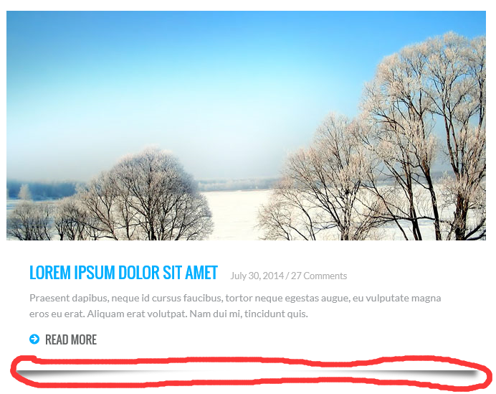

1. Search. Visitors can search the blogs which title or content contain the key words.

Fix the bug about the search box in iphone sadari.

1. Add some useful link in the right banner. Make sure every link is right.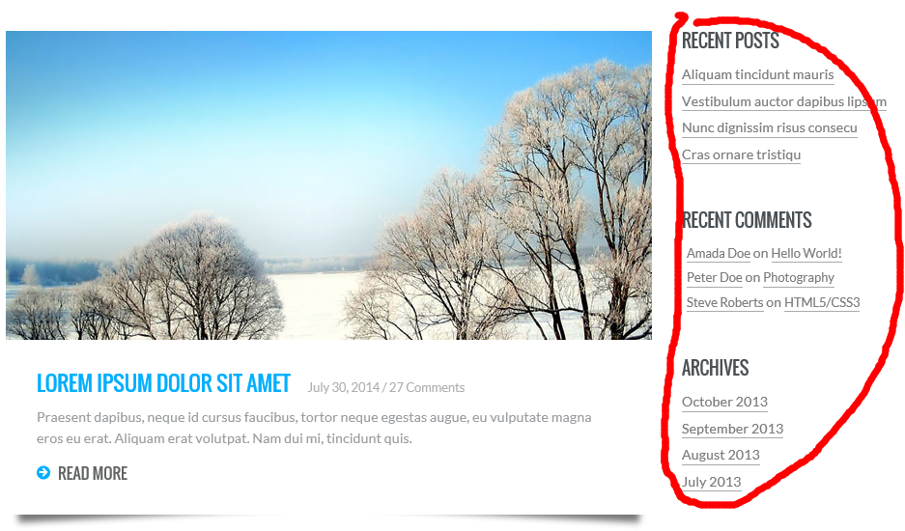
2. Make the fonts loading speed more quick, not from google’s website.
3. Paging ,refer to blogbus.
4. About page ,Show my information, static page
5. Contact page, do a *message board*, refer to qq zone (draw a picture). And ‘find us here ‘ panel retain, it is cool.
6. Backend page,
7. Add content
8. Delete content
9. Edit content

# Database design